Project Design Phase
Solution Architecture
Date | 3 October 2026
Team ID
Project Name | Implement Client Script & UI Policy (Incident)
Maximum Marks | 4 Marks
Solution Architecture:
Solution architecture is a complex process – with many sub-processes – that bridges the gap between business problems and technology solutions. Its goals are to:
- Find the best tech solution to solve existing business problems.
- Describe the structure, characteristics, behavior, and other aspects of the software to project stakeholders.
- Define features, development phases, and solution requirements.
- Provide specifications according to which the solution is defined, managed, and delivered.
Solution Architecture Diagram:
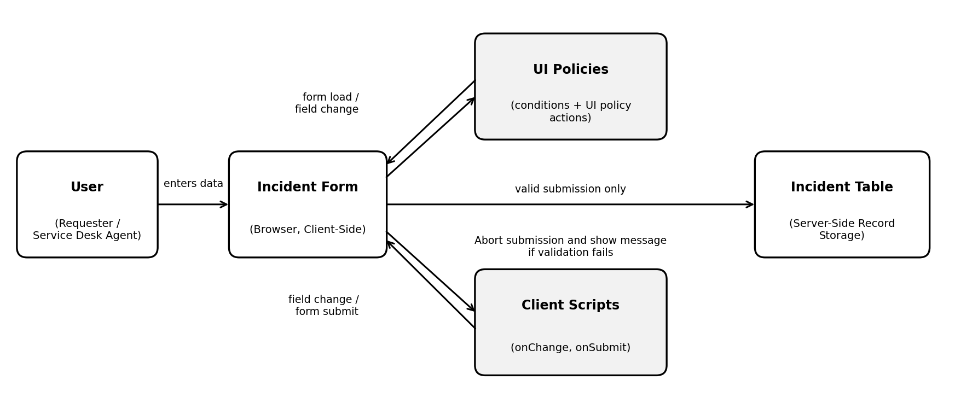
Figure 1: Architecture and data flow of client-side validation on the Incident form
Reference: https://www.servicenow.com/docs/r/platform-administration/t_CreateAUIPolicy.html

